**Introduction to Generative Pre-trained Transformer (GPT)**

The**Generative Pre-trained Transformer (GPT)** is a model, developed by Open AI to understand and generate human-like text. GPT has revolutionized how machines interact with human language, enabling more intuitive and meaningful communication between humans and computers. In this article, we are going to explore more about Generative Pre-trained Transformer.

**Table of Content**

* [What is a Generative Pre-trained Transformer?](https://www.geeksforgeeks.org/introduction-to-generative-pre-trained-transformer-gpt/#what-is-a-generative-pretrained-transformer)
* [Background and Development of GPT](https://www.geeksforgeeks.org/introduction-to-generative-pre-trained-transformer-gpt/#background-and-development-of-gpt)
* [Architecture of Generative Pre-trained Transformer](https://www.geeksforgeeks.org/introduction-to-generative-pre-trained-transformer-gpt/#architecture-of-generative-pretrained-transformer)
* [Training Process of Generative Pre-trained Transformer](https://www.geeksforgeeks.org/introduction-to-generative-pre-trained-transformer-gpt/#training-process-of-generative-pretrained-transformer)
* [Applications of Generative Pre-trained Transformer](https://www.geeksforgeeks.org/introduction-to-generative-pre-trained-transformer-gpt/#applications-of-generative-pretrained-transformer)
* [Advantages of GPT](https://www.geeksforgeeks.org/introduction-to-generative-pre-trained-transformer-gpt/#advantages-of-gpt)
* [Ethical Considerations](https://www.geeksforgeeks.org/introduction-to-generative-pre-trained-transformer-gpt/#ethical-considerations)
* [Conclusion](https://www.geeksforgeeks.org/introduction-to-generative-pre-trained-transformer-gpt/#conclusion)

**What is a Generative Pre-trained Transformer?**

GPT is based on the transformer architecture, which was introduced in the paper "*Attention is All You Need*" by Vaswani et al. in 2017. The core idea behind the[transformer](https://www.geeksforgeeks.org/transformer/)is the use of[self-attention mechanisms](https://www.geeksforgeeks.org/self-attention-in-nlp/) that process words in relation to all other words in a sentence, contrary to traditional methods that process words in sequential order. This allows the model to weigh the importance of each word no matter its position in the sentence, leading to a more nuanced understanding of language.

As a generative model, GPT can produce new content. When provided with a prompt or a part of a sentence, GPT can generate coherent and contextually relevant continuations. This makes it extremely useful for applications like creating written content, generating creative writing, or even simulating dialogue.

**Background and Development of GPT**

The progress of GPT (Generative Pre-trained Transformer) models by OpenAI has been marked by significant advancements in natural language processing. Here’s a chronological overview:

1. **GPT (June 2018)**: The original GPT model was introduced by OpenAI as a pre-trained transformer model that achieved state-of-the-art results on a variety of natural language processing tasks. It featured 12 layers, 768 hidden units, and 12 attention heads, totaling 117 million parameters. This model was pre-trained on a diverse dataset using unsupervised learning and fine-tuned for specific tasks.
2. **GPT-2 (February 2019)**: An upgrade from its predecessor, GPT-2 featured 48 transformer blocks, 1,600 hidden units, and 25 million parameters in its smallest version, up to 1.5 billion parameters in its largest. OpenAI initially delayed the release of the most powerful versions due to concerns about potential misuse. GPT-2 demonstrated an impressive ability to generate coherent and contextually relevant text over extended passages.
3. **GPT-3 (June 2020)**: GPT-3 marked a massive leap in the scale and capability of language models with 175 billion parameters. It improved upon GPT-2 in almost all aspects of performance and demonstrated abilities across a broader array of tasks without task-specific tuning. GPT-3's performance showcased the potential for models to exhibit behaviors resembling understanding and reasoning, igniting widespread discussion about the implications of powerful AI models.
4. **GPT-4 (March 2023)**: GPT-4 expanded further on the capabilities of its predecessors, boasting more nuanced and accurate responses, and improved performance in creative and technical domains. While the exact parameter count has not been officially disclosed, it is understood to be significantly larger than GPT-3 and features architectural improvements that enhance reasoning and contextual understanding.

**Architecture of Generative Pre-trained Transformer**

The transformer architecture, which is the foundation of GPT models, is made up of feedforward neural networks and layers of self-attention processes.

Important elements of this architecture consist of:

1. **Self-Attention System:**This enables the model to evaluate each word's significance within the context of the complete input sequence. It makes it possible for the model to comprehend word linkages and dependencies, which is essential for producing content that is logical and suitable for its context.
2. **Layer normalization and residual connections:** By reducing problems such as disappearing and exploding gradients, these characteristics aid in training stabilization and enhance network convergence.
3. **Feedforward Neural Networks:**These networks process the output of the attention mechanism and add another layer of abstraction and learning capability. They are positioned between self-attention layers.

**Detailed Explanation of the GPT Architecture**

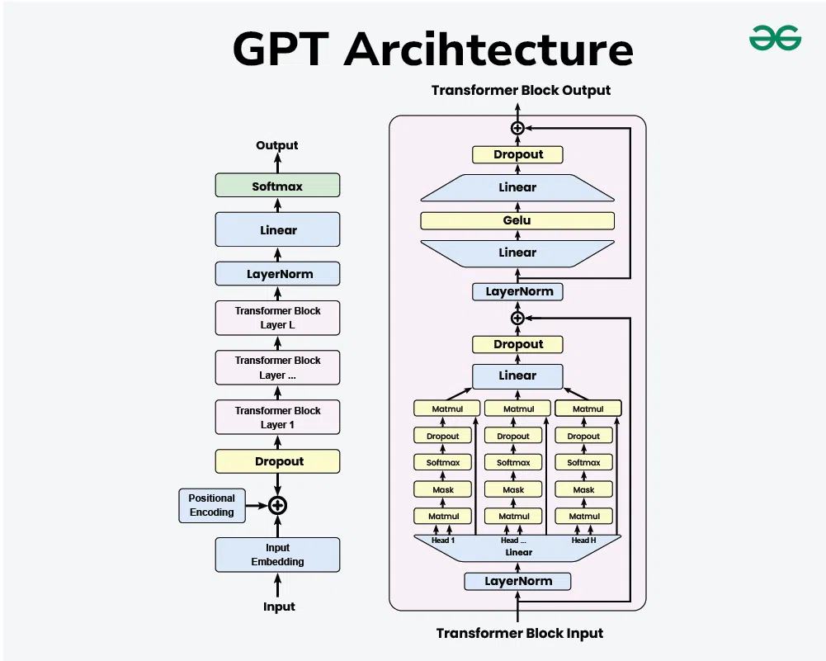

1. **Input Embedding**
   * **Input**: The raw text input is tokenized into individual tokens (words or subwords).
   * **Embedding**: Each token is converted into a dense vector representation using an embedding layer.
2. **Positional Encoding**: Since transformers do not inherently understand the order of tokens, positional encodings are added to the input embeddings to retain the sequence information.
3. **Dropout Layer**: A dropout layer is applied to the embeddings to prevent overfitting during training.
4. **Transformer Blocks**
   * **LayerNorm**: Each transformer block starts with a layer normalization.
   * **Multi-Head Self-Attention**: The core component, where the input passes through multiple attention heads.
   * **Add & Norm**: The output of the attention mechanism is added back to the input (residual connection) and normalized again.
   * **Feed-Forward Network**: A position-wise feed-forward network is applied, typically consisting of two linear transformations with a GeLU activation in between.
   * **Dropout**: Dropout is applied to the feed-forward network output.
5. **Layer Stack:**The transformer blocks are stacked to form a deeper model, allowing the network to capture more complex patterns and dependencies in the input.
6. **Final Layers**
   * **LayerNorm**: A final layer normalization is applied.
   * **Linear**: The output is passed through a linear layer to map it to the vocabulary size.
   * **Softmax**: A softmax layer is applied to produce the final probabilities for each token in the vocabulary.

**Training Process of Generative Pre-trained Transformer**

Large-scale text data corpora are used for unsupervised learning to train GPT algorithms. There are two primary stages to the training:

1. **Pre-training:** Known as language modeling, this stage teaches the model to anticipate the word that will come next in a sentence. In order to make that the model can produce writing that is human-like in a variety of settings and domains, this phase makes use of a wide variety of internet material.
2. **Fine-tuning:** While GPT models perform well in zero-shot and few-shot learning, fine-tuning is occasionally necessary for particular applications. In order to improve the model's performance, this entails training it on data specific to a given domain or task.

**Applications of Generative Pre-trained Transformer**

The versatility of GPT models allows for a wide range of applications, including but not limited to:

1. **Content Creation:**GPT can generate articles, stories, and poetry, assisting writers with creative tasks.
2. **Customer Support:** Automated chatbots and virtual assistants powered by GPT provide efficient and human-like customer service interactions.
3. **Education:**GPT models can create personalized tutoring systems, generate educational content, and assist with language learning.
4. **Programming:**GPT-3's ability to generate code from natural language descriptions aids developers in software development and debugging.
5. **Healthcare:** Applications include generating medical reports, assisting in research by summarizing scientific literature, and providing conversational agents for patient support.

**Advantages of GPT**

1. **Flexibility**: GPT's architecture allows it to perform a wide range of language-based tasks.
2. **Scalability**: As more data is fed into the model, its ability to understand and generate language improves.
3. **Contextual Understanding**: Its deep learning capabilities allow it to understand and generate text with a high degree of relevance and contextuality.

**Ethical Considerations**

Despite their powerful capabilities, GPT models raise several ethical concerns:

1. **Bias and Fairness:** GPT models can inadvertently perpetuate biases present in the training data, leading to biased outputs.
2. **Misinformation:**The ability to generate coherent and plausible text can be misused to spread false information.
3. **Job Displacement:** Automation of tasks traditionally performed by humans could lead to job losses in certain sectors.

OpenAI addresses these concerns by implementing safety measures, encouraging responsible use, and actively researching ways to mitigate potential harms.

**Conclusion**

Artificial intelligence has advanced significantly with the Generative Pre-trained Transformer models, especially in natural language processing. Every version of GPT, from GPT-1 to GPT-4, has increased the capabilities of AI in terms of comprehending and producing human language. Although GPT models' capabilities present a plethora of prospects in a variety of sectors, it is imperative to tackle the ethical issues that come with them in order to guarantee their responsible and advantageous application. GPT models are expected to stay at the vanguard of AI technology evolution, propelling innovation and industry revolution.

"This course is very well structured and easy to learn. Anyone with zero experience of data science, python or ML can learn from this. This course makes things so easy that anybody can learn on their own. It's helping me a lot. Thanks for creating such a great course."-  **Ayushi Jain | Placed at Microsoft**